Module 4

1) Write a program to demonstrate the use of not equal to operator.
Hint: -ne

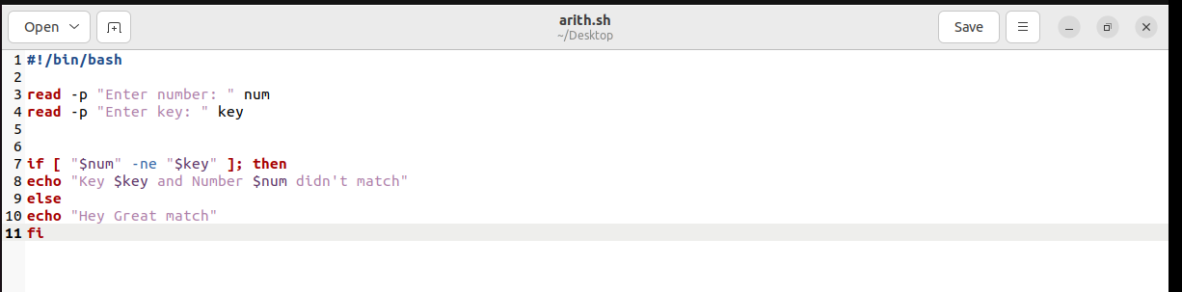
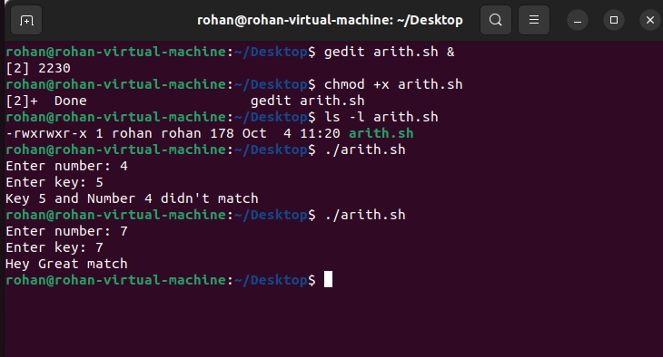

String and File attributes

1) Explore some more attributes
-r
-x
-o

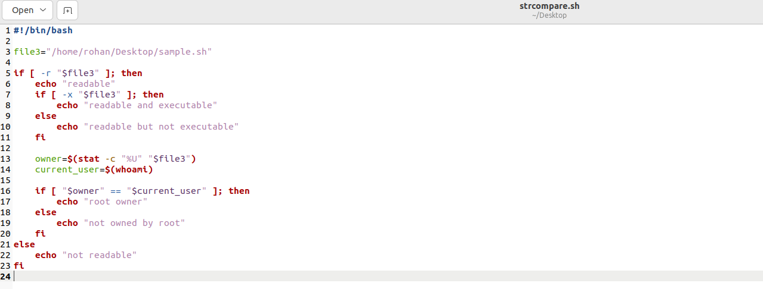
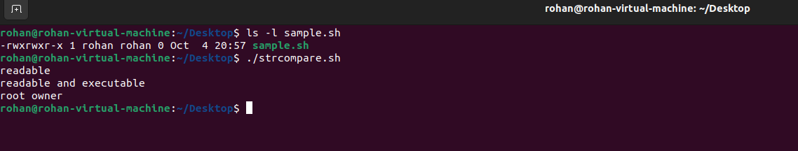

Conditional Loops

1) Find the sum of first n prime numbers.
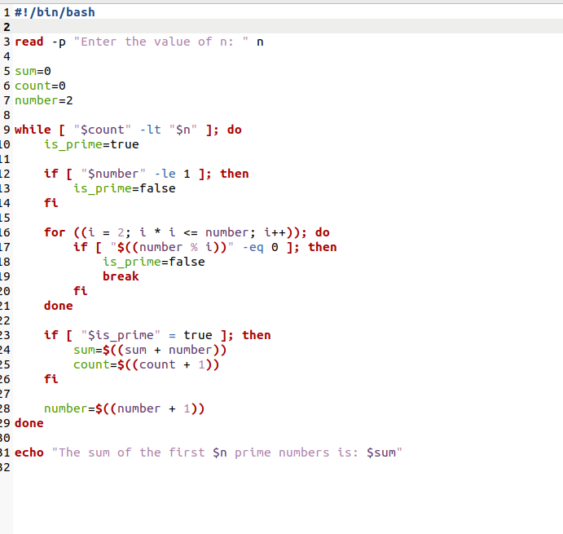

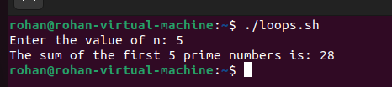

More on Loops

1) Retype nested-for.sh bash script using nested while loop
2) Save your program with the name: nested-while.sh

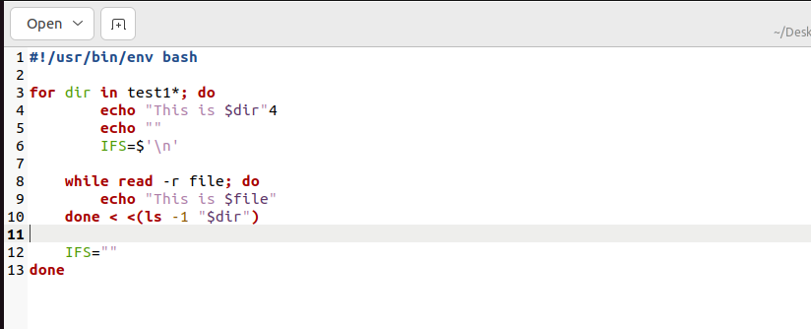
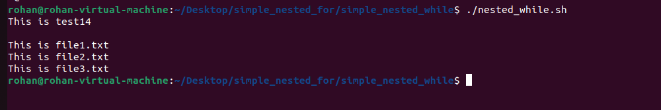

1) Write a menu driven program for mathematical calculation
a. It should take user inputs a and b
b. It should ask for mathematical operator (+, -, / and *).
c. Do the calculation
d. Print the output

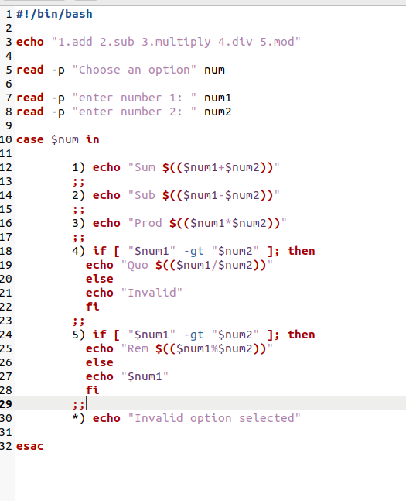

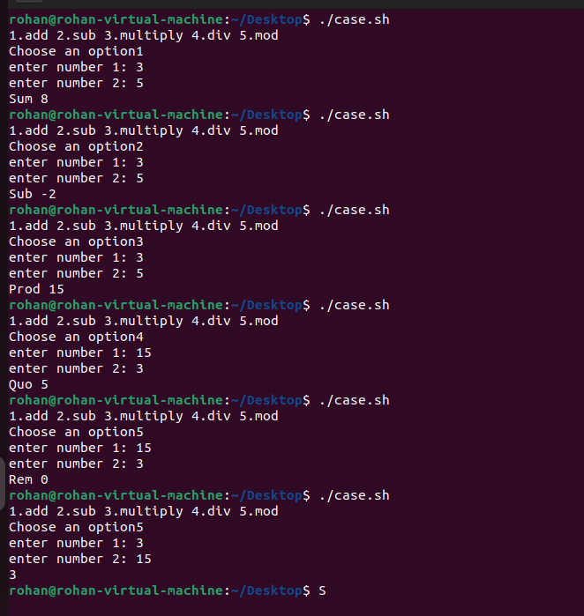

Using File Descriptors

1) Try to append few lines to a file test.txt using file descriptor.
2) Display the content of the file using file descriptor.

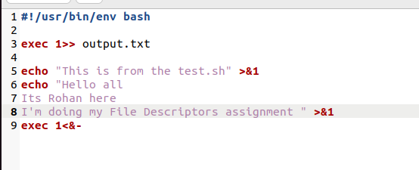
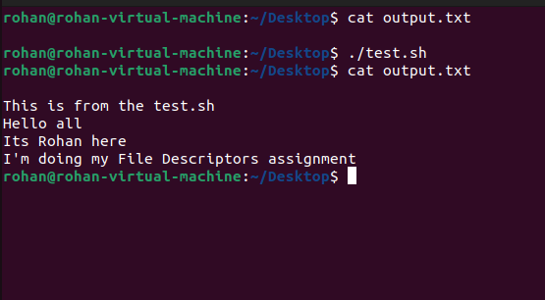

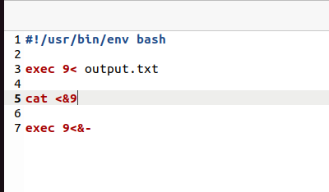

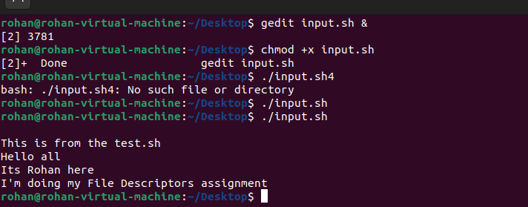

Arrays and functions

1) Write a program,
a. Where a function adds all the elements in an array.
b. The function should display the sum of elements.
c. Make 2 function calls with array elements- (1, 2, 3) and (4, 5, 6).

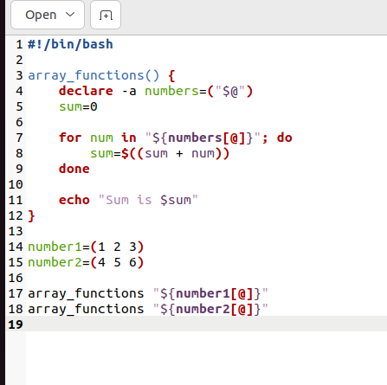
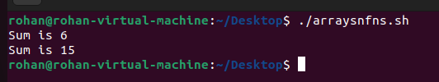

Basics of functions

1) Write a program with two functions:
a. The first function should display diskspace usage in human readable form.
(Hint: df -h)
b. The second function should display filesystem usage in human readable form.
(Hint: du -h)

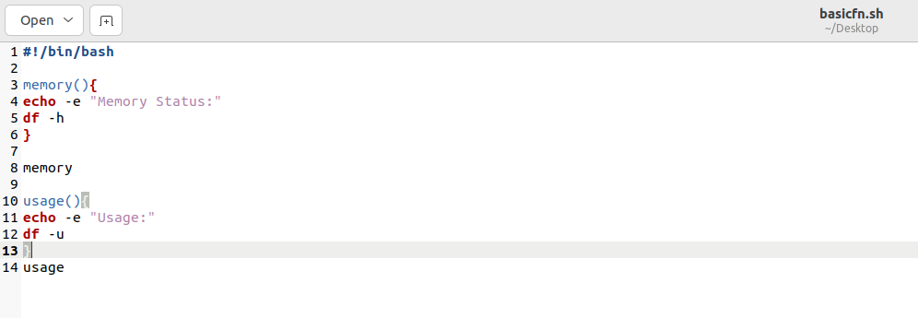
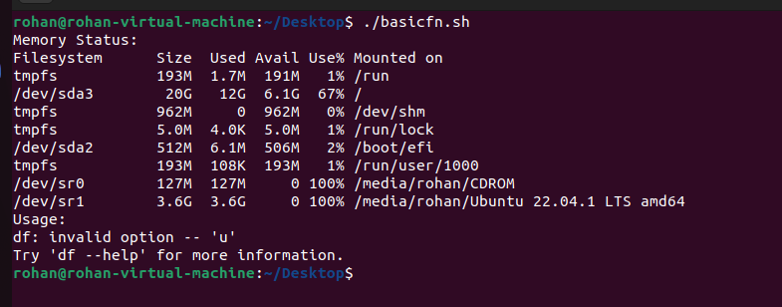

More on functions

1) Write a program,
a. where the function accepts two arguments.
b. The function should multiply the two arguments.
c. Make 3 function calls with arguments - (1, 2), (2, 3) and (3, 4)

